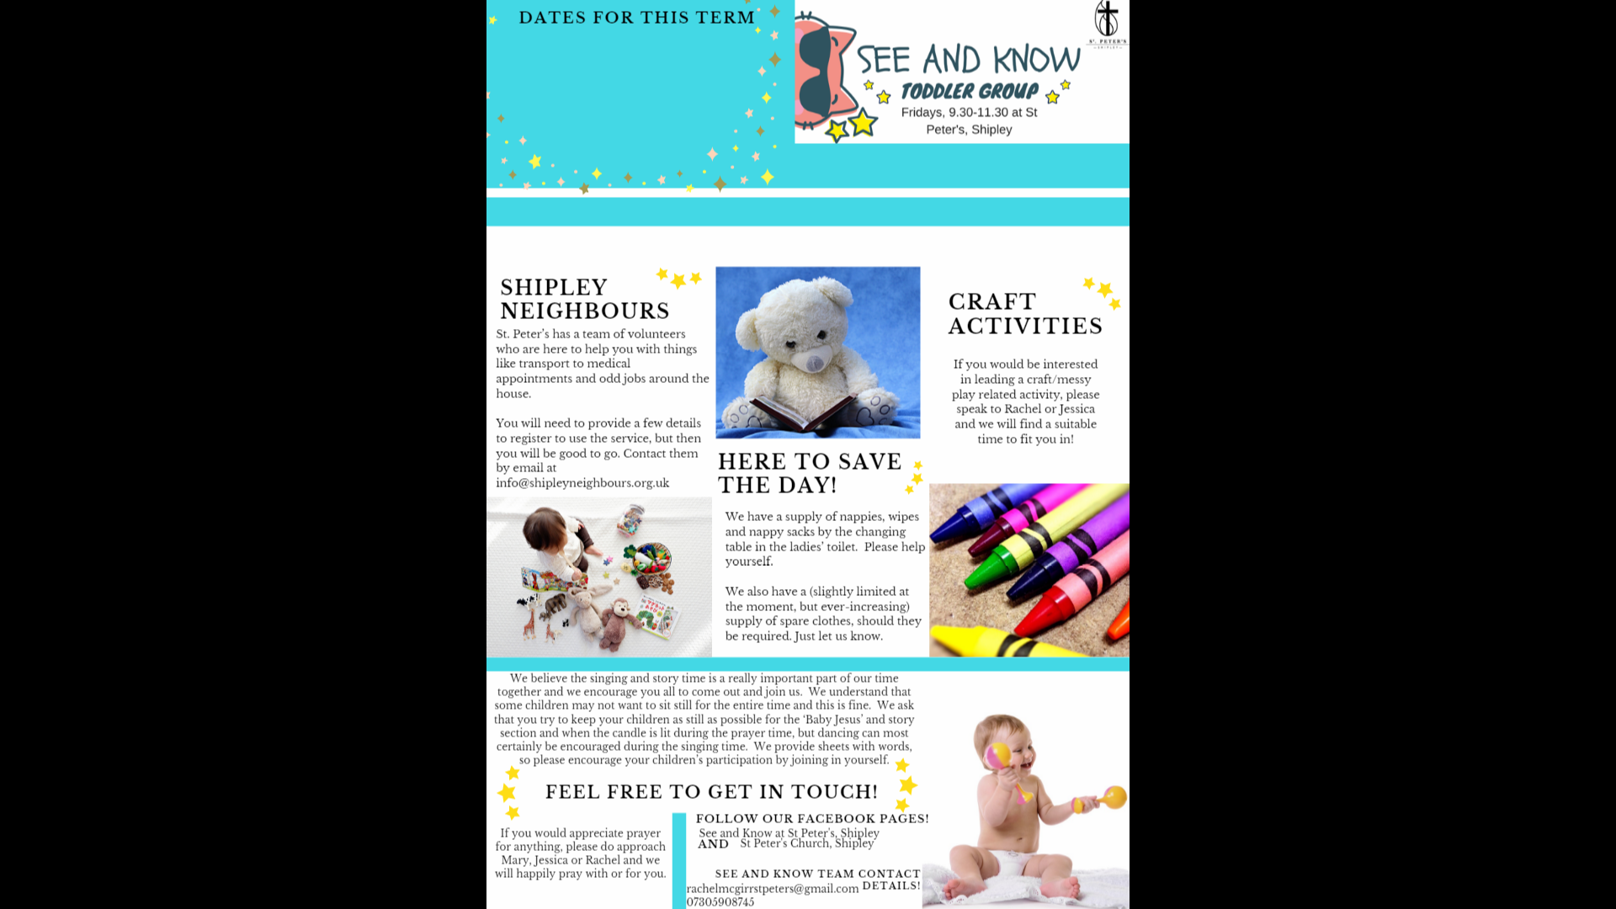

**S&K Weeks**: 8th September – 20th October

**No S&K for half term break:** 27th October

**S&K Weeks**: 3rd November – 15th December

**No S&K for half term break:** 22nd – 29th December We’re Back on 5th Jan 2024!

A u t u m n T e r m 2 0 2 3

**Welcome Back AND A BIG WELCOME TO ALL WHO HAVE RETURNED OR HAVE JOINED US THIS TERM!**

We’re glad you’ve come, and we’ve got some exciting things in store this term to tell you about; things during See and Know, events for your diary as well as info about the regular support that the church offers**.**

A c t i v i t i e s w h i c h a r e r e t u r n i n g …



As many of you know we have Welcome Space after See & Know. This is welcome to all. We serve a delicious healthy soup, packed full of all the good stuff on a pay as you feel basis. We also serve hot and cold drinks, with some delicious cake. If you or your child have any allergies, please talk to Annabel as we try and cater to all dietary needs.

Friday’s 11:30am – 2pm

Welcome Space

At St Peter’s we host a whole range of uniformed groups. They include, Rainbows, Brownies, Guides, Beavers, Cubs and Scouts. If you have other little ones that may be interested please contact the church office, so they can forward you to the correct person.

**Uniformed Groups**



What goes on at See & Know!

See & Know is a toddler group run by

members of St. Peter’s Church. We are so glad

you have chossen to spend your morning with

us and in this wonderful building central to life in Shipley.

We begin with free play (Tea and Coffee available to the left of

the church as you look at the big stained glass window, as well as

crumpets, if you or your child have an allergies, please make sure

you’ve popped it on your child’s enrolment

form or ask Jessica or Liz to update it).

We have tidy-up time and snack at about 10.30am before

finishing off with a structured singing and storytime. There are

some See & Know specific songs, but we also sing traditional nursery

rhymes. We do provide words if you don’t know some of the songs. Please speak to Jessica or Liz for a copy.

p.t.o



Messy Church

Messy Church is back! We’ve missed you all over the summer period and are looking forward to welcoming you back! Messy Church is a fun-filled event for all the family. Messy Church has a mixture of crafts, games, songs, stories and other exciting activities. It takes place on the third Sunday of the month from 3.30pm - 5.45pm, beginning with drinks and finishing with a delicious home cooked meal. If you would like to know more please talk to Jessica ([families@stpetes.org.uk](mailto:families@stpetes.org.uk)) and she’ll be able to tell you everything you’ll need to know

All ages welcome and it's free!

**Dates for this term:**

15th October

19th November

10th December

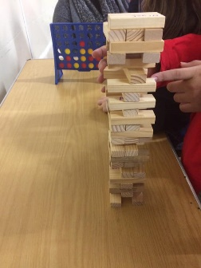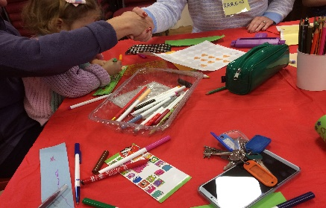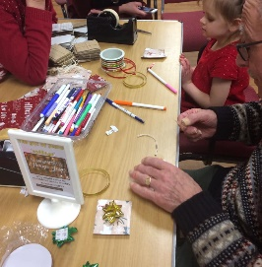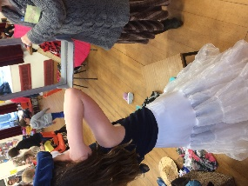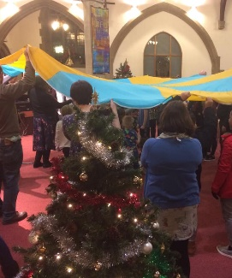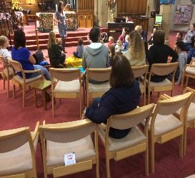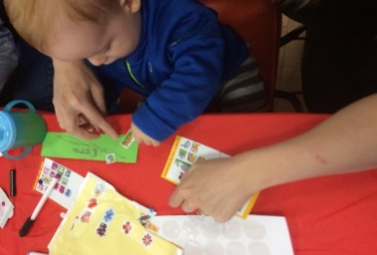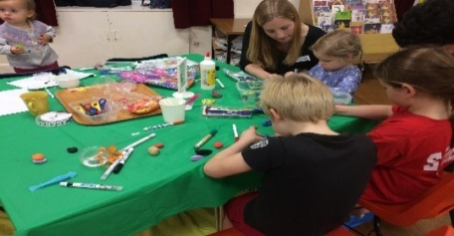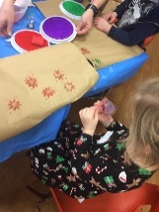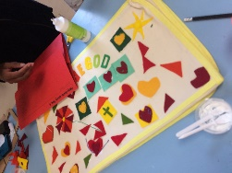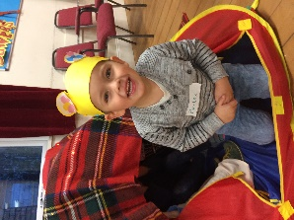

**Don't forget!**

We have a supply of

nappies, wipes, bags

and hand gel under the

changing mat in the

creche.  Please help

yourself!

**Prayer**

If you would appreciate prayer for anything, please do approach Jessica, Liz & Jenni and we will happily pray with or for you.

Helpful Information

**Contact Details:**

Email: [families@stpetes.org.uk](mailto:families@stpetes.org.uk)

**\*please make sure these addresses are in your safe contact list and not spam folder!\***

Phone: 01274 400381 (Church Office)

**Reminder..**

* We would like to remind you that your child/children remain your responsibility at all times.
* Please keep them out of the toy cupboard, especially after tidy-up time.
* During singing time, please join in to encourage all children to engage with this fun, interactive part of the morning.
* Please make use of the hand sanitiser to continue to keep everyone safe.
* Please don't park buggies in front of the fire exits as this will hinder an orderly escape in the (extremely unlikely) event of a fire. Smaller buggies/push along trikes can be parked neatly inside the church (rather than the foyer). Incidentally, the fire assembly point is at the bottom of the church car park, by the fire assembly point sign.

**Milestones**

We love to mark milestones. Please make sure we have your child’s date of birth so we can celebrate their birthday, if you and they would like this.

We also give leaving presents and a special send-off to children when they leave to go to nursery or school.

Please let us know when your child’s last session will be, so that we can say a big goodbye to them.