|  |  |
| --- | --- |
| new logo  **The vision of St Peter’s Church is to see the town of Shipley changed by the power of God. We want to see this happen through a Church which is filled with the power of the Holy Spirit and committed to the Word of God, which serves others in order to bring God’s Kingdom. We want St Peter’s to become a key transforming community bringing about this change, as a church alive with the joy of knowing and worshipping Jesus Christ.** | **Sunday 24th September 2023**  **Sixteenth after Trinity**  Image result for Harvest Picture  **Worship This Sunday**    **HARVEST CELEBRATION**  **9.30am All Age**  Looking to Jesus : ABRAHAM  Genesis 12.1-3  **11.00am Morning Worship**  Looking to Jesus : ABRAHAM  Genesis 12.1-3  1 Peter 2.1-17  (Andy Thorby)  **6.30pm Holy Communion**  Testifying to God’s work  Acts 26.1, 9-25  Mark 9.30-37  (Rev. Brian Greenfield)  ***Following Jesus – making disciples – serving others*** |

|  |  |  |
| --- | --- | --- |
| **This week: 25th September – 1st October** | | |
| Thursday | 10.00am Diane’s Exercise Class | Lounge |
| Friday | 9.00am See & Know  11.00am Welcome Space  7.30pm Choir practice | Church  Lounge  Lounge |
| Saturday | 8.45am Hotaire Band Practice  5.30pm Prayer Meeting for the church | Church  Hope Chapel |
| **Sunday 1st October**  **Generosity Week** | 9.30am All Age  11.00am Holy Communion with Rev. Jenny Ramsden  6.30pm Evening Worship | Church  Church  Church |

**Daily Prayer and Readings**

Online Morning Prayer will begin again on Mondays, Wednesdays and Fridays from September 4th. This takes place at 9am on those days on the St Peter’s page on Facebook – you can join live or watch the recording later. The set readings for the week are as follows. You can find the liturgy for prayers on our website here.

|  |  |  |  |  |  |
| --- | --- | --- | --- | --- | --- |
| **25th September 2023 – 30th September 2023** | | | | | |
| **Monday** | **Tuesday** | **Wednesday** | **Thursday** | **Friday** | **Saturday** |
| **Morning Prayer** | | | | | |
| Ps. 44  Ezekiel 1:1-14  Mark 12. 28 - 34 | Ps. 48  Ezekiel 1 :15-22  Mark 12. 35 - end | Ps. 119. 57 - 80  Ezekiel 2:3—3:11  Mark 13. 1 - 13 | Ps. 57  Ezekiel 3:12-end  Mark 13. 14 - end | Ps. 34; 150  Daniel 12:1-4  Acts 12. 1 - 11 | Ps. 68  Daniel 12:1-4  Mark 13. 32 - end |
| **Evening Prayer** | | | | | |
| Ps. 47  Acts 19. 8 - 20 | Ps. 50  Acts 19. 21 – end | Ps. 59  Acts 20. 1 - 16 | Ps. 62  Acts 20:17-end | Ps. 138; 148  Rev. ch. 5 | Ps. 66  Acts 21:17-36 |

|  |
| --- |
| **Notices this week** |

**Prayer meetings for the next period of St. Peters**

As we prepare for the future following John’s retirement, we believe the most important thing we can do is to come together to pray. As part of this, there will be a prayer meeting at 5:30pm every Saturday until further notice. This will last around 30-45 minutes and take place in the Hope Chapel or church and will be an informal prayer time, focussing on God’s wisdom and guidance for our next stage as a church. If you would be willing to lead the prayer meetings, please contact Jenni [office@stpetes.org.uk](mailto:office@stpetes.org.uk), all help will be greatly appreciated.

**A message from John & Julie Rainer**

John and Julie would like to thank everyone who helped to make their last Sunday so memorable, especially all who worked so hard to produce the amazing cakes and lunch after the service. Thank you too for your very generous gifts to us as we move to the Wirral at the end of September. Thank you to everyone for being part of our journey here, and we leave with lots of great memories and good friends.

Our new address from 27.9.23 will be 19 Stapleton Avenue, Greasby, Wirral, CH49 2QT.

**Harvest Festival**

This Sunday – September 24 – is our Harvest Thanksgiving and we will be giving thanks to God for his provision for us in all our services this week. If you would like to bring some gifts to church as a sign of your thanksgiving for God’s bounty to us, we will be supporting the Bradford North Foodbank’s Harvest Appeal. Please see the attached flyer for details of these collections which will be vital in helping feed people through the rest of the year. Particular needs are for**tinned or packet soup, sugar (any size bags – to be split down at the warehouse), tinned fruit or vegetables, UHT milk, UHT fruit juice (not from the chiller cabinet) and razors/shaving foam.** Please do bring gifts this Sunday if you are able which we will receive during the service and place at the front of church for delivery to the foodbank. After Sunday, please pop them in the food bank basket by the main door.

**Active Seniors**

Sadly, the last meeting of Active Seniors took place this week. We are hugely grateful to the group leaders, Jeanne Evans, Angela Tate and Pam Terry, who have served this group faithfully and done some fantastic work among this age group for some time. They all need to step aside from this work now and we thank them for all they have done. Unfortunately, no one else has been able to be found to volunteer to take this work on at this time and so Active Seniors will no longer be meeting. We will be exploring what alternative provision can be made available through Welcome Space and, if anyone is interested in volunteering to potentially restart Active Seniors, please do talk to Viv, Mike, Karen or one of the wardens.

**See & Know**

We desperately need volunteers to help serve tea’s and coffee’s and butter some lovely crumpets. If you are able to spare a couple of hours on a Friday morning, please speak to Jessica or Jenni ([families@stpetes.org.uk](mailto:families@stpetes.org.uk) 01274400381). We also thank all our wonderful volunteers who have helped See & Know grow into a community event that’s accessible to all. Thank you. Jessica, Liz and all the See & Know team 😊 😊 😊 😊 😊 😊

**Welcome Space**

Please sign up to the rotas at the back of church on the Welcome desk if you are able to volunteer! We need people to help in the kitchen, people to talk to other people, welcome people into the building, bake cakes, wash up or even give donations to help keep this valuable service going! Scan this QR Code to donate! Please speak to Annabel ([annabel.rigby@stpetes.org.uk](mailto:annabel.rigby@stpetes.org.uk)) for more information.

**Welcome Space & Macmillan Coffee Morning**

We’re hosting a Macmillan Coffee Morning! Join us and do whatever it takes to support people with cancer. You are all invited! Taking place on Friday 29th September, St Peter’s Church Lounge, 10am – 2pm! Thanks, Welcome Space Team!

**Home Groups at St. Peter’s**

We would like to review our small group provision for Bible Study, prayer and support at St Peter’s and, as a first step, would like to conduct an audit of home groups currently meeting. As groups were unable to meet face to face during the pandemic, we know many changed their arrangements, some have gone back to meeting regularly again since and others have not restarted. To help us to get a clear current picture, if you are involved in leading a home group, please could you fill in the form on the Welcome Desk at the back of church to give us current details of your group? If you could complete this by Sunday 24 September, that would be very helpful. Thank you.

**Save the date – Emily Milwain**

Baby Emily will be baptised at Bradford Cathedral on Sunday 29th October in the 10.30am service, followed by food to celebrate! Kerry and Duncan would love it if a good bunch of their St Peter’s family could join them for this important event, so pop it in your diary!

There is a sign-up sheet at the back of church where you can let us know whether you are coming along, would like food and/or would like a lift.

**Joy**

Aquabox are increasing their support for the next Yemen container, excellent news as that is more shelter boxes with water filters and

basic family support supplies. Thank you to all of you who support St Peter’s very own aid organisation!!! 😊 Kathy

**Live@Costa**

Sunday 1st October at Costa Café, Market Street, Shipley 6.30pm -8.30pm. Live@Costa is back after a summer break with an evening of

gospel music featuring 'Created for Praise'. Organised by Shipley

Christians Together. Entry is Pay as You Feel (suggested donation £5 for wage earners) with Costa refreshments on sale. All welcome.

More information from [info@shipleychristianstogether.org.uk](mailto:info@shipleychristianstogether.org.uk)

**Shipley Christians Together Annual Meeting**

All are invited to a service and AGM for SCT at St Margaret's Church, Shipley Fields Road, Frizinghall on Sunday 15 October at 6.30 pm.  There remains an ongoing need for trustees for SCT; if this is something you are interested in, please speak to Hugh Firman, SCT Trustee, or to one of the staff team.

**Small Hall Renovations**

Hive have moved in and the room looks wonderful! If you are interested in any of their courses please look at [Front Page - Hive Bradford](https://hivebradford.org.uk/). Thank you to everyone who’s volunteered, baked cakes, donated money to get the Small Hall looking in tip top form (See photos on the next page!)! Thanks again, Staff Team and Hive!

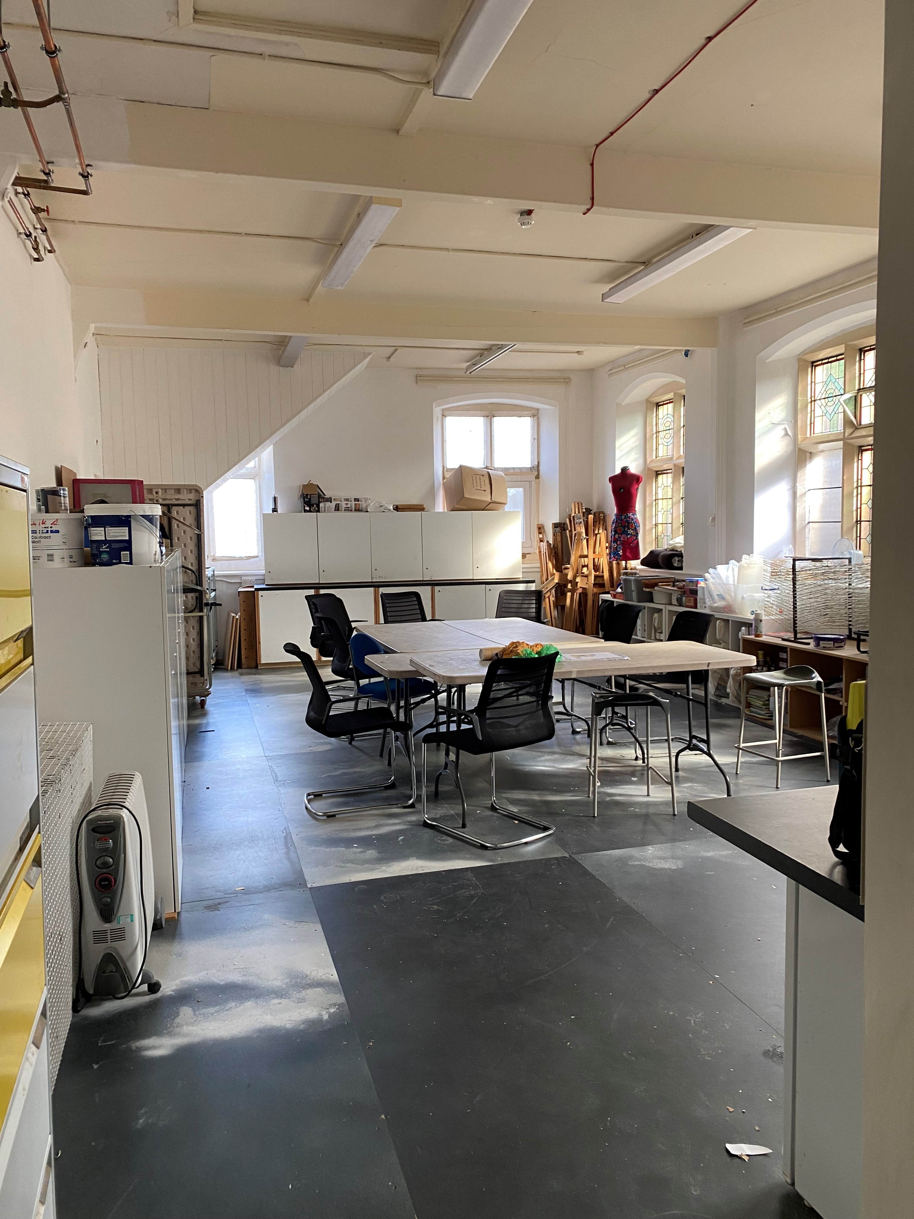

**Saturday Morning Prayers**

Saturday zoom prayers, half an hour or so of online prayers will start on Saturday 9 September at 10 am.  All are welcome whether a new, regular, or occasional member as we pray for each other, the church, community and wider world. If you want any further information please ring Gemma Richards on 07743122828, or Andy Thorlby on 01274 510951. You shouldn't need a password but if you do it is hello

Topic: Saturday zoom prayers

Time: Sep 9, 2023 10:00 AM Greenwich Mean Time

Every week on Sat, until Sep 30, 2023,  - Sep 9, 2023 10:00 AM, Sep 16, 2023 10:00 AM,  Sep 23, 2023 10:00 AM Sep 30, 2023 10:00 AM

Join Zoom Meeting

<https://us04web.zoom.us/j/76539700637?pwd=pyaQenSxiFLbnMeWZd40PqjqNU3Z09.1>

Meeting ID: 765 3970 0637 Passcode: hello

**Eco Tip**

At harvest we can thank God for all the food produced locally. Eating seasonally, and locally, is one of the biggest things you can do to reduce the impact of your diet on the planet.  Do you have an eco-tip or challenge to share? Please email [gemmarichards15@hotmail.com](mailto:gemmarichards15@hotmail.com)

**Disability Training**

The Diocesan Disability Team invite you to their next training session: The Church, Neurodiversity and Me.

How can the church better welcome and value neurodiversity?

We will be learning from people who have personal experience of neurodiversity about the difficulties they have encountered within church and how we can better welcome and value people’s diverse gifts. There will be time for questions and sharing best practice, as well as worship.

This session will be delivered twice, once in-person and once online, so please pick whichever option suits you best:

**30th September, 11.10am-2.30pm – Holy Trinity, Meanwood, Leeds, LS6 4LF** – [Click here](https://learning.leeds.anglican.org/event/the-church-neurodiversity-and-me/) for more information or

**4th November, 10am-12pm – Online via Zoom** – [Click here](https://learning.leeds.anglican.org/event/the-church-neurodiversity-and-me-online/) for more information.

If anyone is interested in participating, to contact Jo Baxter (The Disability Officer for St Peter’s) Thank you.

**Bradford North Foodbank – Shipley**  
Thank you for your ongoing support to the foodbank.

As we celebrate Harvest at St Peter's, please pray for our harvest collections across the area, which will be vital in helping us feed people through the rest of the year.

The foodbank has spent nearly £14,000 buying food in the 5 months to the end of August (compared to £1,800 last year). **If you'd prefer to give financially instead of with food items the details are below.** Gift Aid forms are available from the Welcome Desk if you are able to top-up your donation in this way.

**Bradford North Foodbank**

**Sort code: 08-92-99**

**Account: 65960075**

**Please include 'St Peters' as the reference so we can link this back**

Please pray for the increasing number of families we're feeding at Shipley foodbank - back to school costs have affected many. You may have heard Sue say last week that 60% of those we feed are in families with children and that we fed 2,900 in the year to the end of August - a 63% increase on the previous year.

At the moment we especially need:**instant mash, tinned or packet soups, tinned fruit, UHT milk, UHT fruit juice (not from the chiller cabinet), cleaning items (cloths, sponges) and razors/shaving foam.**

Finally please also continue to donate empty washing up liquid bottles and strong carrier bags.

Please continue to pray for the work of the foodbank, the people who come, the  
staff, and volunteers who give their time to support and listen to people in need.  
Thank you. Anthea, Pete, Stuart and Sue.

**PRAYER REQUESTS**

Pray for those who are ill or have other needs, especially members of St. Peter’s family: Barbara Arkley, Dave Atkin, Lis Bals, Alison Barnard, Jo Baxter, Maureen Bragg, Sue Dent, Hazel Fawley, Glenys Gillow, Moira Gledhill, Lorna Hartley, Gina Hearne, Ian Hearne (Gina’s son), Rowena and Keith Hodgson, Pat Hornby, Barbara Lehane, Val Ross, Joyce Taylor, Joan Yeates & Ursula Moore.

**Mission Partner News**

Please pray for all the mission partners this week. As we celebrate harvest this week, please pray they are all able to be nourished, spiritually, emotionally and physically with the help of our lord and saviour Jesus Christ.

|  |
| --- |
| **A HELPING HAND** |

We operate a Helping Hands Fund for any member of our congregation struggling financially. This is there to help with short term one- off needs. You can pick up a leaflet with more information from the welcome desk

or church office or contact Mandy Thorlby (mandythorlby@gmail.com, or 07801 138180). If you'd like to donate to the Helping Hands Fund, please contact Andy Thorlby  thorlbya@yahoo.co.uk   or 01274 510951, or make a donation in the usual way into the church, clearly identified as “Helping Hands Fund”.

**This Church operates a Safeguarding Policy in line with national and diocesan guidelines. Our Safeguarding Officer is Frances Vose, T: (07972647427), E: safeguarding@stpetes.org.uk. Child Line can be contacted on 0800 1111.**

|  |  |  |  |
| --- | --- | --- | --- |
| **CONTACT ST. PETER’S**  **DAY OFF** | | | |
| **Vicar** | Vacant | 01274  584488 |  |
| **Associate Priest** | Brian Greenfield | 01274  788345 | Friday or  Saturday |
| **Licensed Lay Minister** | Viv Brealey 07519 552231 | | |
| **Treasurer** | Mike Moss 07758 575653 | | |
| **Churchwardens** | Mervyn Silva 01274 419815  Gemma Richards 07743 122828 | | |
| **Children & Youth Work** | Children’s & Youth Administrator: Jenni Reid  01274 400381 or [office@stpetes.org.uk](mailto:office@stpetes.org.uk)  Children’s work Co-ordinator: Jessica Criddle [Jessica.criddle@stpetes.org.uk](mailto:Jessica.criddle@stpetes.org.uk) or via the office | | |
| **Shipley Neighbours** | 01274 400381 | | |
| **Pastoral Co-ordinators** | Carol Brown  Keith Brown | 01274  585242 |  |
| **Church Office** | Jennifer Reid  Mon – Fri  9.00am –12.30pm | 01274  400381 |  |
| email.jpg | office@stpetes.org.uk | | |
| website.jpg | www.stpetes.org.uk | | |
| Facebook's New Apple Watch App Kit Lets You Stay in Touch ... | [St. Peter's Church Shipley](https://www.facebook.com/profile.php?id=100064368892299) | | |