|  |  |
| --- | --- |
| new logo  **The vision of St Peter’s Church is to see the town of Shipley changed by the power of God. We want to see this happen through a Church which is filled with the power of the Holy Spirit and committed to the Word of God, which serves others in order to bring God’s Kingdom. We want St Peter’s to become a key transforming community bringing about this change, as a church alive with the joy of knowing and worshipping Jesus Christ.** | **Sunday 17th September 2023**  **Fifteenth after Trinity**  Image result for september flowers  **Worship This Sunday**      **11.00am Holy Communion**  Looking to Jesus : NOAH  Genesis 6. 9 – 7.24  Matt. 24.36-44  (The Ven Andy Jolley)  **3.30pm Messy Church**  Noah    ***No evening service today***  ***Following Jesus – making disciples – serving others*** |

|  |  |  |
| --- | --- | --- |
| **This week: 18th September – 24th September** | | |
| Monday | 10.10am Vicky Scott’s Funeral  11.30am Barbara Dyer’s service of celebration | Nab Wood Crematorium  Church |
| Wednesday | 1.00pm NHS Blood Service | Church |
| Thursday | 10.00am Diane’s Exercise Class | Lounge |
| Friday | 9.00am See & Know  11.00am Welcome Space  7.00pm Youthie  7.30pm Choir practice | Church  Lounge  Lounge  Church |
| Saturday | 8.45am Hotaire Band Practice  5.30pm Prayer Meeting for the church | Church  Hope Chapel |
| **Sunday 24th September**  **HARVEST CELEBRATION** | 9.30am All Age  11.00am Morning Worship  6.30pm Holy Communion with Rev. Brian Greenfield | Church  Church  Church |

**Daily Prayer and Readings**

Online Morning Prayer will begin again on Mondays, Wednesdays and Fridays from September 4th. This takes place at 9am on those days on the St Peter’s page on Facebook – you can join live or watch the recording later. The set readings for the week are as follows. You can find the liturgy for prayers on our website here.

|  |  |  |  |  |  |
| --- | --- | --- | --- | --- | --- |
| **18th September 2023 – 23rd September 2023** | | | | | |
| **Monday** | **Tuesday** | **Wednesday** | **Thursday** | **Friday** | **Saturday** |
| **Morning Prayer** | | | | | |
| Ps. 30  Zech. Ch. 10  Mark 11. 1 - 11 | Ps. 36  Zech. 11. 4 – end  Mark 11. 12 - 26 | Ps. 34  Zech. 12. 1 - 10  Mark 11. 27 - end | Ps. 49; 117  1 Kings 19. 15- end  2 Tim. 3. 14 - end | Ps. 31  Zech. 41. 1 - 11  Mark 12. 13 - 17 | Ps. 42  Zech. 14. 18 - 27  Mark 12. 18 - 27 |
| **Evening Prayer** | | | | | |
| Ps. 28  Acts 16. 6 - 24 | Ps. 33  Acts 16. 25 – end | Ps. 119. 33 -56  Acts 17. 1 - 15 | Ps. 119. 33 - 40  Matt. 19. 16 - end | Ps. 35  Acts 18. 1 - 21 | Ps. 46  Acts 18.22 – 19.7 |

|  |
| --- |
| **Notices this week** |

**Prayer meetings for the next period of St. Peters**

As we prepare for the future following John’s retirement, we believe the most important thing we can do is to come together to pray. As part of this, there will be a prayer meeting at 5:30pm every Saturday until further notice. This will last around 30-45 minutes and take place in the Hope Chapel or church and will be an informal prayer time, focussing on God’s wisdom and guidance for our next stage as a church. If you would be willing to lead the prayer meetings, please contact Jenni [office@stpetes.org.uk](mailto:office@stpetes.org.uk), all help will be greatly appreciated.

**Barbara Dyer**

Barbara’s funeral service will be on **Monday 18th September**. A private funeral at Nab Wood will be followed by a service of celebration for her life, in church at **11.30am. Please be aware if you are able to park in the surrounding streets and walk in we would be very grateful as we expect the service to be busy. Thank you**

**Vicky Scott**

We are sorry to have to inform you that Vicky Scott, who has been a member of St Peter's for many years, died on Tuesday morning following a long stay in hospital. She had been taken ill whilst visiting family in Sunderland.

Please pray for Keith (her husband) and their family at this time.

The funeral will take place at 10.10am on Monday 18th September at Nab Wood Crematorium.

**A message from John & Julie Rainer**

John and Julie would like to thank everyone who helped to make their last Sunday so memorable, especially all who worked so hard to produce the amazing cakes and lunch after the service. Thank you too for your very generous gifts to us as we move to the Wirral at the end of September. Thank you to everyone for being part of our journey here, and we leave with lots of great memories and good friends.

Our new address from 27.9.23 will be 19 Stapleton Avenue, Greasby, Wirral, CH49 2QT.

**Harvest Festival**

Next Sunday – September 24 – will be our Harvest Thanksgiving and we will be giving thanks to God for his provision for us in all our services next week. If you would like to bring some gifts to church as a sign of your thanksgiving for God’s bounty to us, we will be supporting the Bradford North Foodbank’s Harvest Appeal. Please see the attached flyer for details of these collections which will be vital in helping feed people through the rest of the year. Particular needs are for**tinned or packet soup, sugar (any size bags – to be split down at the warehouse), tinned fruit or vegetables, UHT milk, UHT fruit juice (not from the chiller cabinet) and razors/shaving foam.** Please do bring gifts next week if you are able which we will receive during the service and place at the front of church for delivery to the foodbank.

**Welcome Space**

Please sign up to the rotas at the back of church on the Welcome desk if you are able to volunteer! We need people to help in the kitchen, people to talk to other people, welcome people into the building, bake cakes, wash up or even give donations to help keep this valuable service going! Scan this QR Code to donate! Please speak to Annabel ([annabel.rigby@stpetes.org.uk](mailto:annabel.rigby@stpetes.org.uk)) for more information. On a separate note; Thank you to everyone who helped pitch in last week whilst Annabel and Jenni were very poorly. They’re both feeling much better and really appreciate all of your support!

**Welcome Space & Macmillan Coffee Morning**

We’re hosting a Macmillan Coffee Morning! Join us and do whatever it takes to support people with cancer. You are all invited! Taking place on Friday 29th September, St Peter’s Church Lounge, 10am – 2pm! Thanks, Welcome Space Team!

**Messy Church**

"Today is Messy Church. We are looking at Noah and learning that just like Noah and his family needed to be inside the ark to be saved from the flood, so we need to be hidden in Christ to be saved from God's judgement. I am very much looking forward to sharing the gospel with the children and adults who attend. Please pray that the Holy Spirit would be softening the hearts of those who come to hear and want to respond to his invitation of salvation.

I am, however, in **desperate** need of more volunteers. At time of writing, I only have one person to lead a table activity and I have four different activities planned. If you could help, please let me know either by email ([jessica.criddle@stpetes.org.uk](mailto:jessica.criddle@stpetes.org.uk)) or phone/text (07786940921). You would need to be available from 3pm until 4.45pm, although you could stay later (until 6pm) and get fed!"

**Home Groups at St. Peter’s**

We would like to review our small group provision for Bible Study, prayer and support at St Peter’s and, as a first step, would like to conduct an audit of home groups currently meeting. As groups were unable to meet face to face during the pandemic, we know many changed their arrangements, some have gone back to meeting regularly again since and others have not restarted. To help us to get a clear current picture, if you are involved in leading a home group, please could you fill in the form on the Welcome Desk at the back of church to give us current details of your group? If you could complete this by Sunday 24 September, that would be very helpful. Thank you.

**Bradford North Foodbank – Shipley**  
Thank you for your ongoing support to the foodbank.

Pete Criddle is taking on responsibility for food collections from St Peter's - as well as the collection point in the entrance at church you can drop donations at the Criddle's house - 3 Springhurst Road, BD18 3DN - there's a labelled box behind the bins to the left of the front door if no-one is home and you can contact Pete on 07921 611750 if you've any foodbank questions or need donations to be collected from your house.

As we move into the autumn, please pray for our harvest collections across the area, which will be vital in helping us feed people through the rest of the year.

At the moment we especially need:**tinned or packet soups, tinned fruit or vegetables, UHT milk, UHT fruit juice (not from the chiller cabinet), cleaning items (cloths, sponges) and razors/shaving foam.**

Please continue to pray for the work of the foodbank, the people who come, the  
staff, and volunteers who give their time to support and listen to people in need.  
Thank you. Anthea, Pete, Stuart and Sue.

**Joy**

I am desperate for help even for short term volunteers to help in the Shipley JOY shop on a Tuesday. Its in Westgate opposite the Virgin bank, and we’d love to see you either as customers, or just to browse in our much praised book shop part. Please do support us. Thank you all, Kathy

**Shipley Open Gardens**

Shipley Open Gardens raised over £3000 for the Children's Society back in June. Many thanks to all who supported this lovely event.  Helen Scott

**Save the date – Emily Milwain**

Baby Emily will be baptised at Bradford Cathedral on Sunday 29th October in the 10.30am service, followed by food to celebrate! Kerry and Duncan would love it if a good bunch of their St Peter’s family could join them for this important event, so pop it in your diary!

There is a sign-up sheet at the back of church where you can let us know whether you are coming along, would like food and/or would like a lift.

**Small Hall Renovations**

Hive have moved in and the room looks wonderful! If you are interested in any of their courses please look at [Front Page - Hive Bradford](https://hivebradford.org.uk/). Thank you to everyone who’s volunteered, baked cakes, donated money to get the Small Hall looking in tip top form (See photos on the next page!)! Thanks again, Staff Team and Hive!

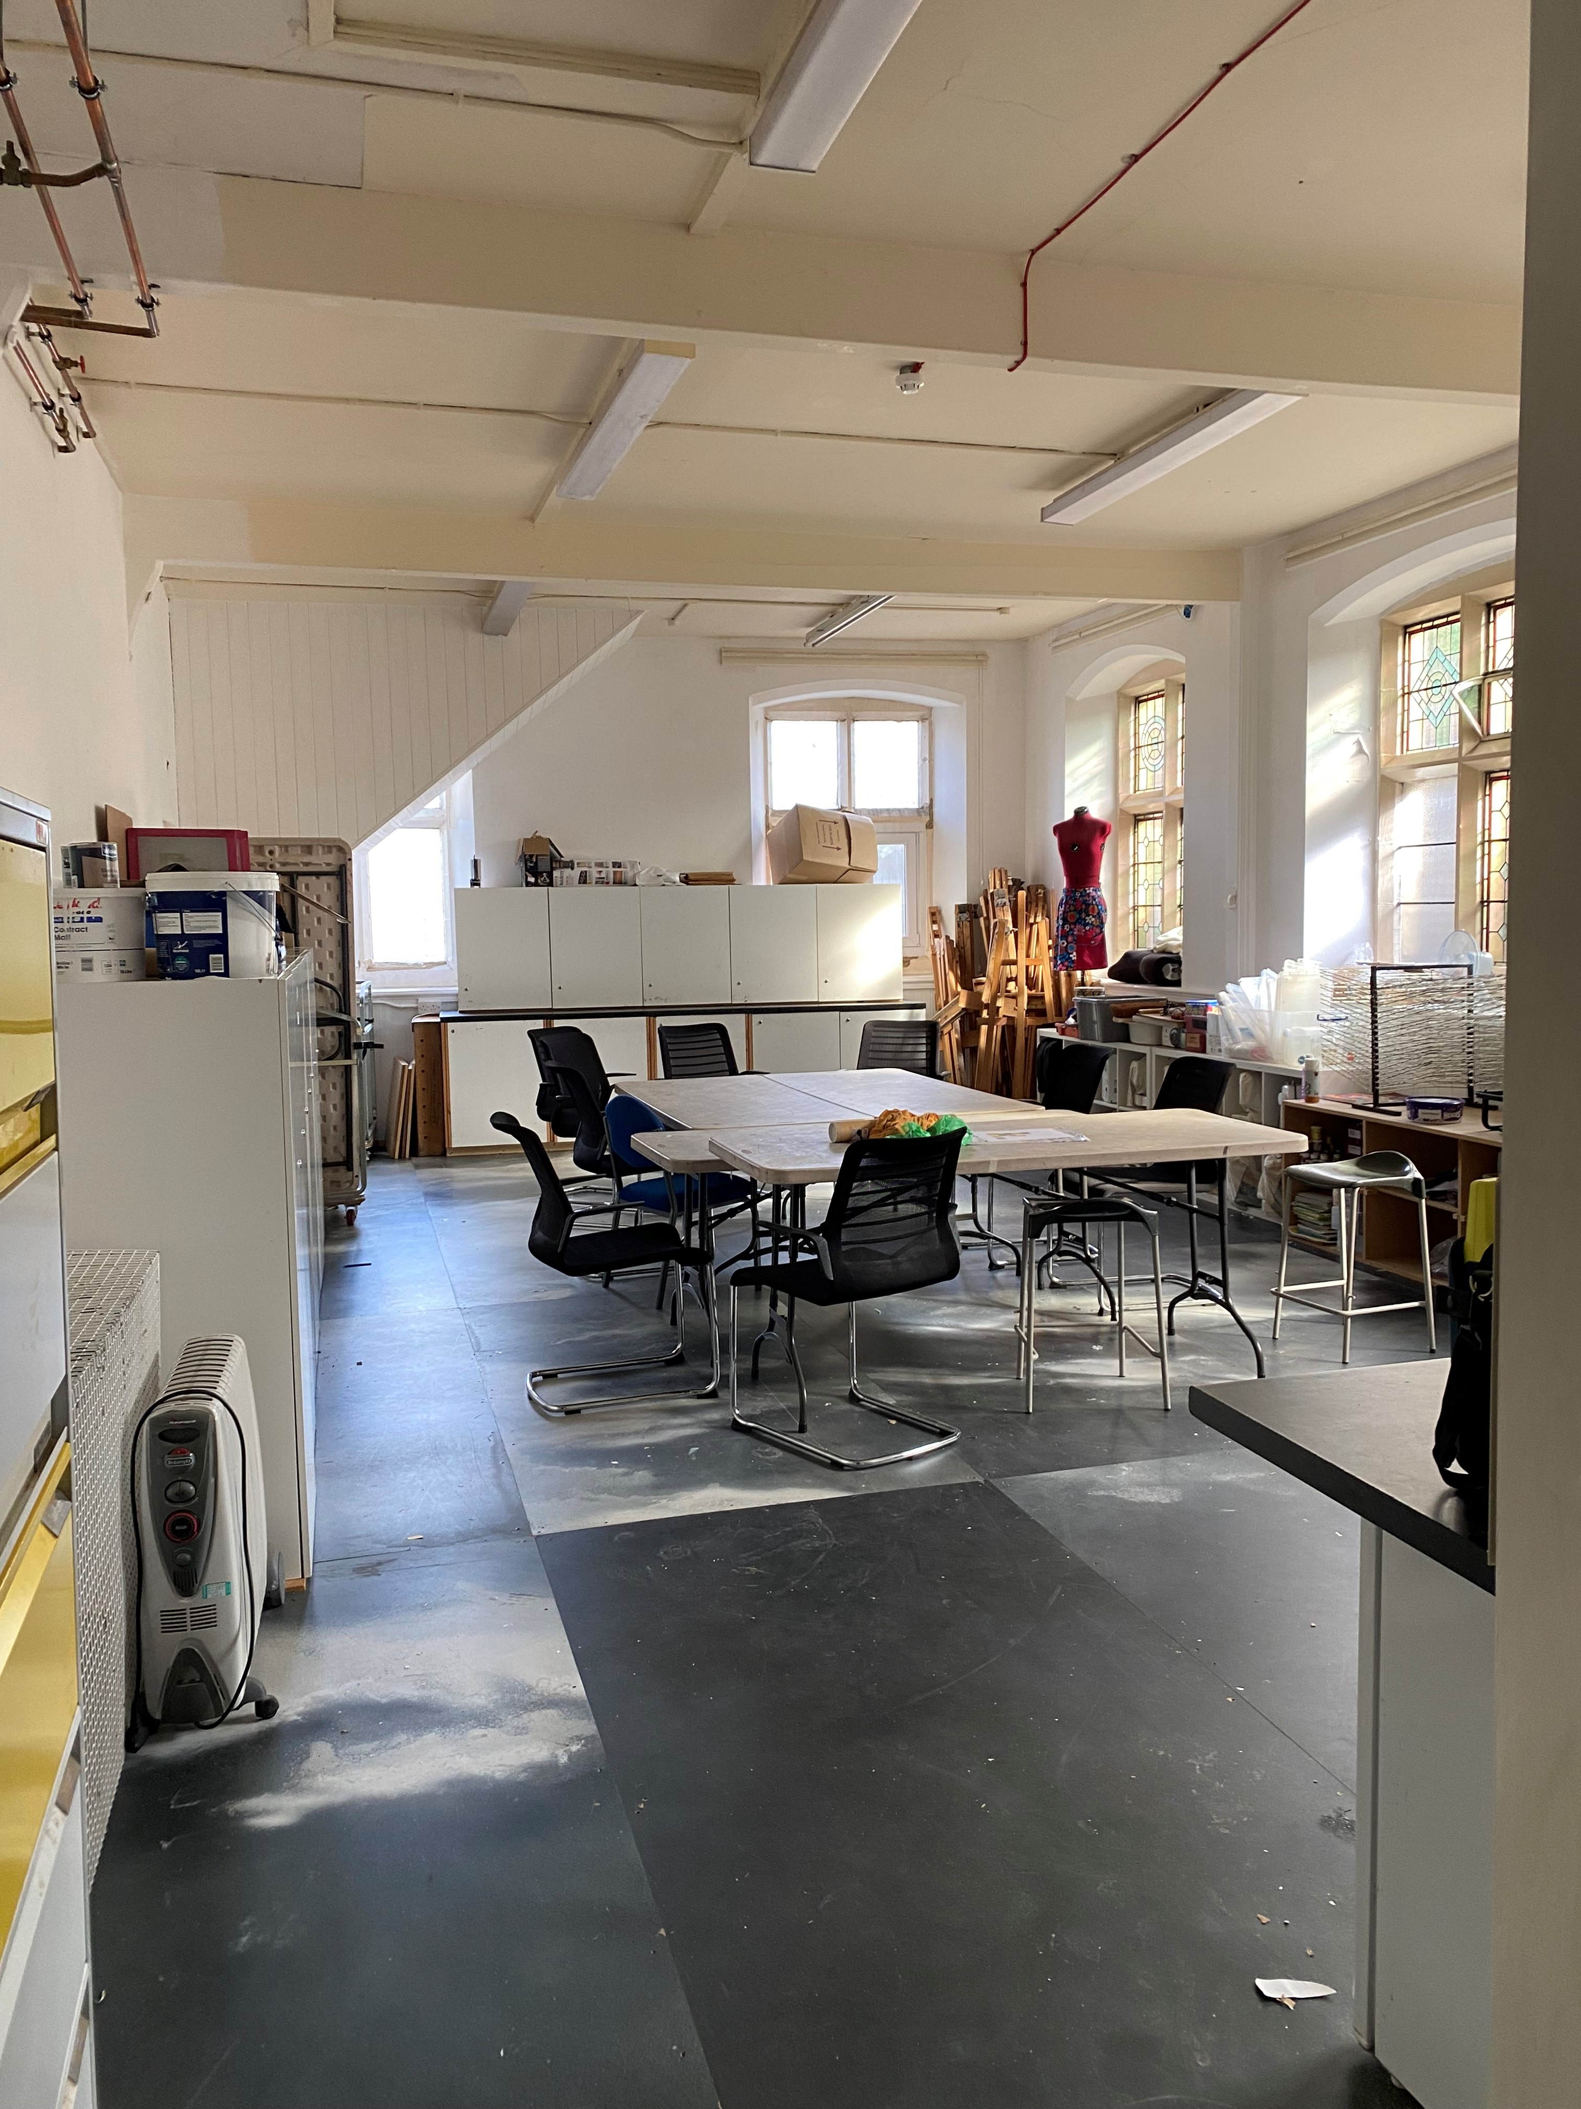

**Saturday Morning Prayers**

Saturday zoom prayers, half an hour or so of online prayers will start on Saturday 9 September at 10 am.  All are welcome whether a new, regular, or occasional member as we pray for each other, the church, community and wider world. If you want any further information please ring Gemma Richards on 07743122828, or Andy Thorlby on 01274 510951. You shouldn't need a password but if you do it is hello

Topic: Saturday zoom prayers

Time: Sep 9, 2023 10:00 AM Greenwich Mean Time

Every week on Sat, until Sep 30, 2023,  - Sep 9, 2023 10:00 AM, Sep 16, 2023 10:00 AM,  Sep 23, 2023 10:00 AM Sep 30, 2023 10:00 AM

Join Zoom Meeting

<https://us04web.zoom.us/j/76539700637?pwd=pyaQenSxiFLbnMeWZd40PqjqNU3Z09.1>

Meeting ID: 765 3970 0637 Passcode: hello

**Eco Tip**

This week's tip comes from Hugh Firman.  Tools With a Mission collects your unwanted tools for use in African countries.

See <https://www.twam.uk/donatetools> for more information about what is and isn't wanted, for example broken is ok but not with woodworm,  or contact local drop off points in Shipley, [howardc@twam.uk](mailto:howardc@twam.uk) or Bingley, [Chrisa@twam.uk](mailto:Chrisa@twam.uk)

**Live@Costa**

Sunday 1st October at Costa Café, Market Street, Shipley 6.30pm -8.30pm. Live@Costa is back after a summer break with an evening of

gospel music featuring 'Created for Praise'. Organised by Shipley

Christians Together. Entry is Pay as You Feel (suggested donation £5 for wage earners) with Costa refreshments on sale. All welcome.

More information from [info@shipleychristianstogether.org.uk](mailto:info@shipleychristianstogether.org.uk)

**Disability Training**

The Diocesan Disability Team invite you to their next training session: The Church, Neurodiversity and Me.

How can the church better welcome and value neurodiversity?

We will be learning from people who have personal experience of neurodiversity about the difficulties they have encountered within church and how we can better welcome and value people’s diverse gifts. There will be time for questions and sharing best practice, as well as worship.

This session will be delivered twice, once in-person and once online, so please pick whichever option suits you best:

**30th September, 11.10am-2.30pm – Holy Trinity, Meanwood, Leeds, LS6 4LF** – [Click here](https://learning.leeds.anglican.org/event/the-church-neurodiversity-and-me/) for more information or

**4th November, 10am-12pm – Online via Zoom** – [Click here](https://learning.leeds.anglican.org/event/the-church-neurodiversity-and-me-online/) for more information.

If anyone is interested in participating, to contact Jo Baxter (The Disability Officer for St Peter’s) Thank you.

**PRAYER REQUESTS**

Pray for those who are ill or have other needs, especially members of St. Peter’s family: Barbara Arkley, Dave Atkin, Lis Bals, Alison Barnard, Jo Baxter, Maureen Bragg, Sue Dent, Hazel Fawley, Glenys Gillow, Moira Gledhill, Lorna Hartley, Gina Hearne, Ian Hearne (Gina’s son), Rowena and Keith Hodgson, Pat Hornby, Barbara Lehane, Val Ross, Joyce Taylor, Joan Yeates & Ursula Moore.

**Mission Partner News**

**Garry Ion**

Garry, who is now based in Cumbria, asks for prayer for the Community Shed Project in Carlisle. Many of the men who attend have serious mental health issues, but find an outlet through the activities on offer. Pray that the Bible Study sessions which Garry has introduced will grow in numbers and that the participants will begin to find real faith in Jesus.

|  |
| --- |
| **A HELPING HAND** |

We operate a Helping Hands Fund for any member of our congregation struggling financially. This is there to help with short term one- off needs. You can pick up a leaflet with more information from the welcome desk

or church office or contact Mandy Thorlby (mandythorlby@gmail.com, or 07801 138180). If you'd like to donate to the Helping Hands Fund, please contact Andy Thorlby  thorlbya@yahoo.co.uk   or 01274 510951, or make a donation in the usual way into the church, clearly identified as “Helping Hands Fund”.

**This Church operates a Safeguarding Policy in line with national and diocesan guidelines. Our Safeguarding Officer is Frances Vose, T: (07972647427), E: safeguarding@stpetes.org.uk. Child Line can be contacted on 0800 1111.**

|  |  |  |  |
| --- | --- | --- | --- |
| **CONTACT ST. PETER’S**  **DAY OFF** | | | |
| **Vicar** | John Rainer  (On annual leave to 19/09/23) | 01274  584488 | Friday |
| **Associate Priest** | Brian Greenfield | 01274  788345 | Friday or  Saturday |
| **Licensed Lay Minister** | Viv Brealey 07519 552231 | | |
| **Treasurer** | Mike Moss 07758 575653 | | |
| **Churchwardens** | Mervyn Silva 01274 419815  Gemma Richards 07743 122828 | | |
| **Children & Youth Work** | Children’s & Youth Administrator: Jenni Reid 01274 400381 or [office@stpetes.org.uk](mailto:office@stpetes.org.uk)  Children’s work Co-ordinator: Jessica Criddle [Jessica.criddle@stpetes.org.uk](mailto:Jessica.criddle@stpetes.org.uk) or via the office | | |
| **Shipley Neighbours** | 01274 400381 | | |
| **Pastoral Co-ordinators** | Carol Brown  Keith Brown | 01274  585242 |  |
| **Church Office** | Jennifer Reid  Mon–Fri  9.00am –12.30pm | 01274  400381 |  |
| email.jpg | office@stpetes.org.uk | | |
| website.jpg | www.stpetes.org.uk | | |
| Facebook's New Apple Watch App Kit Lets You Stay in Touch ... | [St. Peter's Church Shipley](https://www.facebook.com/profile.php?id=100064368892299) | | |