  The vision of St Peter’s Church is to see the town of Shipley changed by the power of God. We want to see this happen through a Church which is filled with the power of the Holy Spirit and committed to the Word of God, which serves others in order to bring God’s Kingdom. We want St Peter’s to become a key transforming community bringing about this change, as a church alive with the joy of knowing and worshipping Jesus Christ. | Sunday 4th June 2023  Trinity Sunday  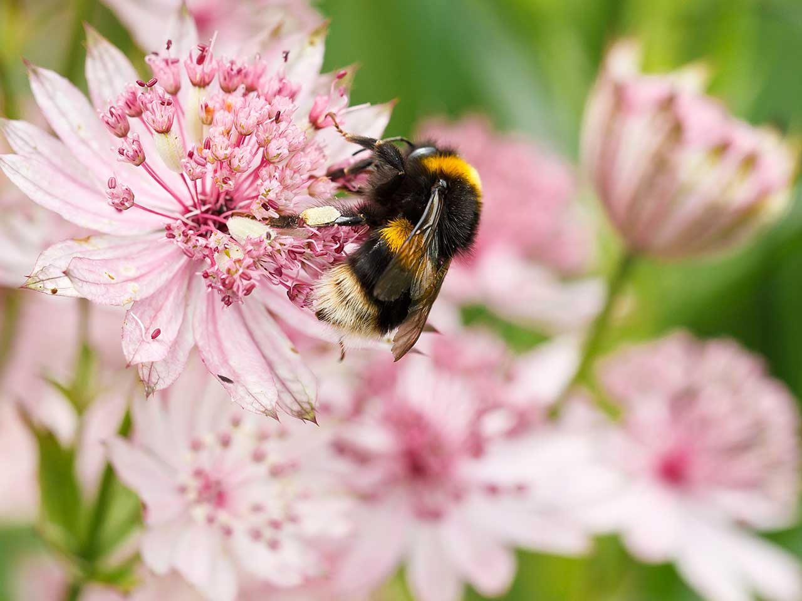  Worship This Sunday  Sunday  9.30 am All Age Worship  Good News for Everyone  Mark 7.24-30  (Mark Davies, David Slaney &  John Rainer)  11.00am Holy Communion  Good News for Everyone  Isaiah 64. 1-12; Mark 7.24 – 30  (John Rainer)  6.30pm Evening Worship: Reset  Good News for Everyone  Isaiah 65. 17-25; Mark 7.31 – 37  (John Rainer)  Following Jesus – making disciples – serving others

This week: 5th June – 11th June
Monday | 9.00am Morning Prayer online  7.00pm CoAnon Family Group  18.45pm Bradford Voice  For more information, please go to www.bradfordvoices.org.uk | Upper Room  Church
Wednesday | 9.00am Morning Prayer online
Thursday | 10.00am Diane’s Exercise Class | Lounge
Friday | 9.00am Morning Prayer online  9.30am See & Know  11.00am Welcome Space | Church  Lounge
Saturday | 8.45am Hot Aire Band practice. If you are interested in becoming a member, please visit: www.hotaire.org | Lounge
Sunday 4th June | 9.30am All Age Holy Communion  11.00am Morning Worship  6.30pm Holy Communion  8.00pm Risen | Church  Church  Church  Upper Room

Daily Readings
Online daily prayers are available on Monday, Wednesday and Friday this week. The set readings for the week are as follows. You can find liturgy for prayers on our website here.

5th June 2023 – 10th June 2023
Monday | Tuesday | Wednesday | Thursday | Friday | Saturday
Morning Prayer
Ps. 1  2 Chron. 26. 1-21  Rom. 4. 1 - 12 | Ps. 5  2 Chron. Ch. 28  Rom. 4. 13 - end | Ps. 119.1- 32  2 Chron. 29. 1 – 19  Rom. 5. 1 - 11 | Ps. 15  2 Chron. 29. 20 - end  Rom. 5. 12 - end | Ps. 19  2 Chron. Ch. 30 Rom. 6. 1 – 14 | Ps. 23  2 Chron. 32. 1 - 22  Rom. 6. 15 - end
Evening Prayer
Ps. 4  Luke 10. 25 - 37 | Ps. 9  Luke. 10. 38 – end | Ps. 11  Luke 11. 1 - 13 | Ps. 18  Luke. 11. 14 – 28 | Ps. 22  Luke. 11. 29 – 36 | Ps. 24  Luke 11. 37 – end
NOTICES

Can u help?

We are looking for individuals and families to link with our Mission Partners. Please talk to John Rainer if you would like to do this.
There is a new system in place for sound and visuals in church, and if you are interested in learning to operate this, please have a word with Mike Moss or Mark Jordan.
Extra helpers are needed at See and Know on Friday mornings. This does not necessarily involve working with the children – please approach Jessica or Liz to discuss this.
If these are not for you, but there is something you'd like to assist with in church, please speak to John or one of the wardens - we'd love to hear from you!
Welcome Space: Fridays 11.00am – 2.00pm
Please do sign up for the volunteering positions on the clipboard on the welcome desk for June. We would like to thank The Orange Grove, Melvyn Davis and Shipley College for their continued support.

If anyone has a spare hand blender, plastic tubs or any other kitchen equipment they’re happy to donate to ‘Welcome Space’ it would be most appreciated. Please speak to Annabel or email her at annabel.rigby@stpetes.org.uk if you can help. Thank you!

See & know
We look forward to seeing you from the half term break! Small request, if anyone is willing to donate a 4 slice toaster that fits crumpets we would be most grateful! Please contact Jessica (jessica.criddle@stpetes.org.uk) if you can help! Thank you, Jessica, Liz and all the see & know team.

Open Gardens – date for your diary.
10th and 11th June, 1-5pm. 17 gardens will be open over the weekend. A lovely occasion in support of The Children's Society. £3 per adult. Programmes are now available on the welcome desk. Helen Scott

St Michaels Cottingley – Songs of praise with the Mothers Union
Sunday 11th June, 4.30pm there will be a free event (donations welcome) of singing, tea & cakes! All are welcome to come and join in. Gina Hearne.
Notice from Duncan Milwain.
Duncan’s ordination is 1st July at Bradford Cathedral at 11.00am. If anyone would like to attend, then seats will be available on a first come, first served basis – and in any event the cathedral has asked that anybody coming has to be seated by 10.45am. As you will probably be aware parking at the cathedral is very limited. If enough people would like to come along then we can look at hiring transport to get to the cathedral. There is a sign-up sheet at the back of church. If people could put their names down by June 18th we can then work out how best to deal with this.

There will also be a ‘do’ back here in the lounge at St. Peter’s starting at 1.45pm. We will be providing savoury food – if anyone would like to bring cake or dessert then that would be welcome! Again, please put your name down on the sign-up sheet if you are happy to contribute. Thank you! Duncan]

Zephaniah Sparks of Hope night - Saturday 10th June
Zephaniah Trust are hosting a "Sparks of Hope" night - with stories from Julie Wilkinson and songs from John Froud. It is sure to be a fun and uplifting evening! Bring your own drinks. 8pm Saturday 10th June (doors open from 7.30), at Shipley Baptist Church. £5 entry. Zephaniah are doing this event as a fundraiser for Bradford Refugee Forum. Please do come along if you can! Thanks Julia.

Live @ Costa
Sunday 4th June Live@Costa at Costa Café, Market Street, Shipley 6.30pm - 8.30pm. Featuring Paul Colman (Grammy nominated and ex The Newsboys) on a World tour from Nashville, USA Organised by Shipley Christians Together. Entry is Pay as you Feel with Costa refreshments on sale. All welcome. More information from info@shipleychristianstogether.org.uk

Beacon’s Refugee Week Walk
The annual Beacon Refugee walk is taking place on Wednesday 21st June. For more information please contact Amanda admin@beaconbradford.org , Mobile; 07506 211756 or alternatively visit their website www.beaonbradford.org/events

Joy
The 9th container is all set to be loaded on June 9th- pray we get everything packed and all the paperwork done by then. Things made difficult in that my car was written off by a speeding Mercedes, so I am without transport; please pray that I can find something I can afford that is Ukraine and is being delivered this week. Bless you all for your support. Kathy

Would you or someone you know like a Bible?
We have a collection of Bibles we need to find a new home for. If you or someone you know would like a Bible from St Peters, please ask a member of the staff team or email Jenni at office@stpetes.org.uk

Bradford North Foodbank – Shipley
A huge thank you for all your donations which help us to be able to continue to
feed people who need help and to signpost them to further support.
Did you know that people from St. Peter's donated 2,176 kg of food in the year to 31 March 2023? This makes food parcels for 103 families, providing 3,153 meals alongside other daily essentials. There is a certificate from the foodbank on display in the new porch.
At the moment we especially need: tinned tomatoes, soup, hot chocolate, tuna, UHT Milk (whole milk and semi skimmed), UHT fruit juice (not from the chiller cabinet), chocolate or sweets, coffee (100g), sugar 1kg, pasta sauce, instant mash.
Please also remember to save and donate empty washing up liquid bottles.
Please continue to pray for the work of the foodbank, the people who come, the
staff, and volunteers who give their time to support and listen to people in need.
Thank you. Anthea, Julie, Pete, Stuart and Sue

Saturday morning prayers
Sadly there’re no online prayers this week. We look forward to seeing you next week!

Eco Tips
Superdrug’s with pharmacies such as Superdrug Keighley can no longer accept bulk collections of medicine blister packs due to storage issues. They will take one carrier bag full. Some doctor's surgeries/vets now accept them including Bingley Medical Practice. If you know of any Shipley locations to recycle blister packs please let me know! Have you an eco tip or challenge to share? Please email gemmarichards15@hotmail.com

PRAYER REQUESTS

Pray for those who are ill or have other needs, especially members of St. Peter’s family: John and Barbara Arkley, Dave Atkin, Lis Bals, Alison Barnard, Jo Baxter, Maureen Bragg, Sue Dent, Hazel Fawley, Glenys Gillow, Moira Gledhill, Lorna Hartley, Gina Hearne, Ian Hearne (Gina’s son), Rowena and Keith Hodgson, Pat Hornby, Barbara Lehane, Val Ross, Joyce Taylor, and Joan Yeates.

Mission Partner News
From Julian Shelton (Wycliffe Bible Translators)
Plans are taking shape for the translators’ team to meet in Tbilisi next month, 9-12 June. We chose a bank holiday weekend in Russia, as it's hard for some to get time off work. Things are always a bit up in the air until the last minute when Yakars are involved, but we really hope it can all go ahead - it's been so long since we last met.
Please pray that nothing will prevent the meeting going ahead. In the interest of building relationships and trust, we're also inviting along the spouses of the local Yakar team members.

Pray that God's word will ring out in all the 500+ languages of Eurasia!

From Chris Howitz in Oman
It has been 4 months since this new church congregation was born. Thank you so much for your ongoing prayers and support.
We would request your continued prayers for the Inaugural Church Meeting (15th June) where we will vote in our church constitution, and four individuals to leadership / council. Please pray for the fellowship through the summer months, where many people will be out of the country at some stage. Please continue to pray for our partnership with the Bible Society Bookshop, that we would be able to realise our dream of having a coffee stop at the back of the Ghala bookshop to encourage Bible engagement.
Please also pray for us, as the person heading up Youth Alpha, The English Cafe, and The Monday Morning Online Prayer, will be moving with his family away from Oman. Please pray that although small in size we would have a big impact for God's kingdom in this place.
Please continue to pray for our finances, that God would provide for our needs according to His resources and His plan.

(Chris is hoping to visit St Peter’s in August.)

Sudan

Please continue to pray for a negotiated settlement to the violence in Khartoum and elsewhere, and for the safety of Archbishop Ezekiel and the Christian community.

Pray for plans to organise a vigil for Sudan at St Peter’s in the near future.

A HELPING HAND

We operate a Helping Hands Fund for any member of our congregation struggling financially. This is there to help with short term one- off needs. You can pick up a leaflet with more information from the welcome desk
or church office or contact Mandy Thorlby (mandythorlby@gmail.com, or 07801 138180). If you'd like to donate to the Helping Hands Fund, please contact Andy Thorlby thorlbya@yahoo.co.uk or 01274 510951, or make a donation in the usual way into the church, clearly identified as “Helping Hands Fund”.

This Church operates a Safeguarding Policy in line with national and diocesan guidelines. Our Safeguarding Officer is Frances Vose, T: (07972647427), E: safeguarding@stpetes.org.uk. Child Line can be contacted on 0800 1111.

CONTACT ST. PETER’S DAY OFF
Vicar | John Rainer | 01274 584488 | Friday
Associate Priest | Brian Greenfield | 01274 788345 | Friday or  Saturday
Licensed Lay Minister | Viv Brealey 07519 552231
Treasurer | Mike Moss 07758 575653
Churchwardens | Mervyn Silva 01274 419815  Gemma Richards 07743 122828
Children & Youth Worker | Vacant
Shipley Neighbours | 07848413941
Pastoral Co-ordinators | Carol Brown  Keith Brown | 01274 585242  01274 585242
Church Office | Mon–Fri  9.00am –12.30pm | 01274 400381
 | office@stpetes.org.uk
 | www.stpetes.org.uk
 | @StPetersShipley
 | /St. Peter's Church Shipley

