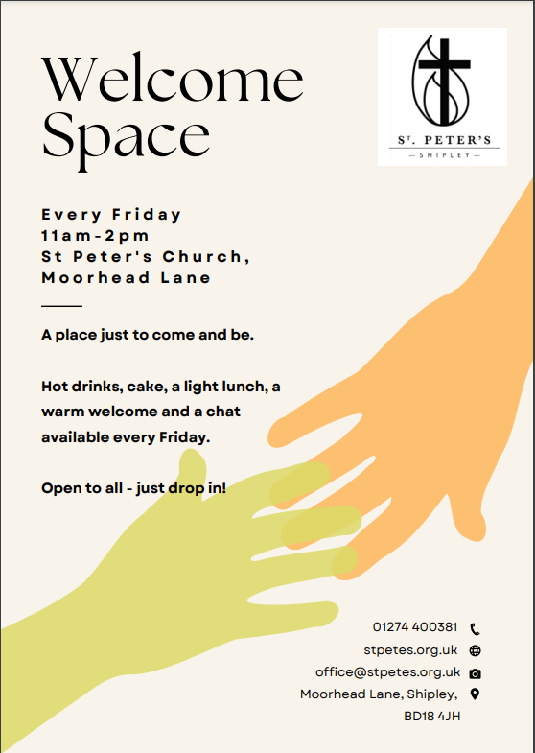
Welcome to Welcome Space!
Hopefully, you are aware that Welcome Space launched on Friday and will be running every week on Fridays in the church halls between 11am and 2pm.
Welcome Space started life as Warm Space last October, when it was part of a national initiative over the winter. Knowing that the steep rise in the cost of living and fuel prices could make this a very hard winter, the intention of Warm Space was to set up community spaces where people could go to find a heated space with refreshments at low or no cost to help them through the colder months.
Warm Space at St Peters opened on October 14 and ran until the end of March, getting through tonnes of cake and vats of soup in the process!
We took a pause at the original end of the project in March to have a look at what the experience had taught us and decide what to do next. The main outcomes were:
- Warm Space was a huge success with a group of incredibly committed volunteers coming along each week and working really hard to make sure it could happen.
- Warm Space was really meeting a need. An average of 50-70 people came along each week, from Mums and young toddlers, coming through for lunch after our Friday See and Know group, to older members of the church enjoying space to chat over lunch on a regular basis, to staff from local shops and businesses popping in at lunchtime. Around half of those attending were not previously linked to St Peter’s.
- In our parish, finding somewhere to belong where you are known by name and can be assured of a friendly chat is a significant need. Beating loneliness and isolation is as much, if not more, of an issue than the economic climate.
- Warm Space gave us far wider opportunities than we ever dreamed of for reaching out to people the church did not have previous links with. As a result of the project, we now have a strong link with Shipley College, with two students on work experience and a teacher from the college coming along each week to help with preparing, serving and clearing up and two more students helping with refreshments for See and Know. Local businesses the Orange Grove and Melvyn Davies Bakers have provided us with soup ingredients and bread each week and we have been able to provide a chef with regular work producing the soup each week at a very small cost.
- Warm Space took a lot of work! We want to say a huge thank you to the team of volunteers, many of whom committed to coming along almost every week, to co-ordinate food, set up, welcome people on the door, chat to visitors, keep the cake table loaded, make endless pots of tea and coffee, serve food, load and unload the dishwasher and clear and tidy up at the end. This was a lot of hard work for a relatively small group of people and we are enormously grateful to them and to those who regularly baked and brought cakes and sweet treats.
Although Warm Space originally began as a project over the winter months, it is clear that there is a real need for it to continue throughout the year. As a result, we are relaunching now as Welcome Space – not that the welcome won’t be warm (and not that the heating won’t be on if required!) but because this is a development of the original project beyond the national Warm Space initiative.
We have reviewed the way the project ran and concluded that we require an overarching co-ordinator who will ensure that all the relevant pieces are in place in each week – which is quite a complex jigsaw – look after volunteer rotas and generally oversee the project. We have some grant funding remaining from the original Warm Space, which will allow us to fund this role for a few hours per week, as well as covering the majority of the costs of providing the sessions, for the next few months. We are also actively seeking further grant funding, which will support this continuing well into the future.
A job description for this role – which will be on a freelance basis for a few hours per week – will be published next week and open for Expressions of Interest from anyone who would be interested in taking it on for the next three months for which we already have guaranteed funding. In the meantime, we are grateful to Annabel Rigby, who has worked with Duncan at Fountains Church in Bradford and on other catering projects, and who has agreed to temporarily look after this role for us for the next few weeks to allow Welcome Space to launch immediately. Do drop in on a Friday and say hello if you are able!
As well as the overall co-ordinator role, we will be looking for volunteers to act as session co-ordinators each week, welcomers, chatters, cake bakers, soup stirrers, dishwasher masters, clearers up and all the other roles that are needed to make the sessions run smoothly each time. Please do look out for the sign-up sheets for all these roles on the Welcome Desk in church and sign up to help out if you are able. Annabel will also be looking to co-ordinate rotas a little further ahead than the ad hoc week to week basis we have used to date.
Last weekend, a member of the congregation passed on a passage she had seen in her daily Bible reading notes and felt was directly speaking to the contribution Warm Spaces has made to our mission as a church. The staff team were very encouraged by this and wanted to share it further with you.
The passage was Acts 28:1-10, which tells how Paul and his companions, travelling by sea to Rome are shipwrecked in a storm and land on the island of Malta. It is cold and wet but the local people build a fire and welcome Paul and his group with warmth and care. Paul, in turn, is then able to offer help and healing to them. Paul and his companions have lost everything in the shipwreck but they are welcomed and looked after and eventually sent on their way with all the provisions they need to continue their journey. No doubt Paul did talk about the gospel while he was there, but Luke’s account of the story focusses on the caring actions that took place – hospitality, warmth, prayer and healing, practical care and help. The notes end with these words: “The strong Maltese church today traces its roots back to this event: a moment when mutual care and compassion sowed the seeds of faith. There is a human warmth here that echoes the warmth of the fire and reflects the warmth of God’s love. In our own times, can we transcend all that divides people and come together in a place of warmth and safety?”
Through Welcome Space, we believe we can continue to do just that here in our own times in Shipley. Please give thanks to God for all that he has already done through this project and continue to pray for his will and vision for the future of this work to grow among us.

