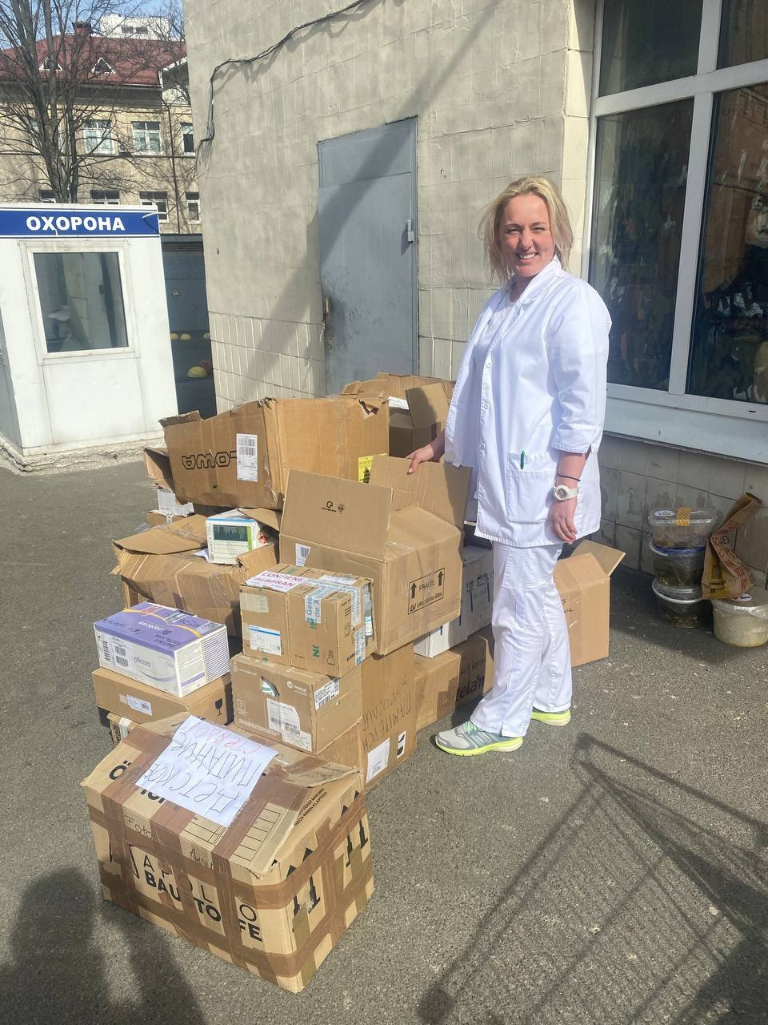
Ukraine
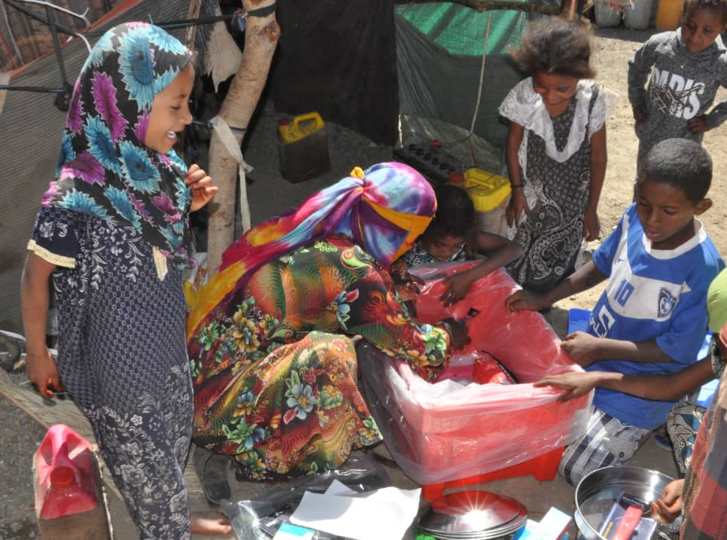
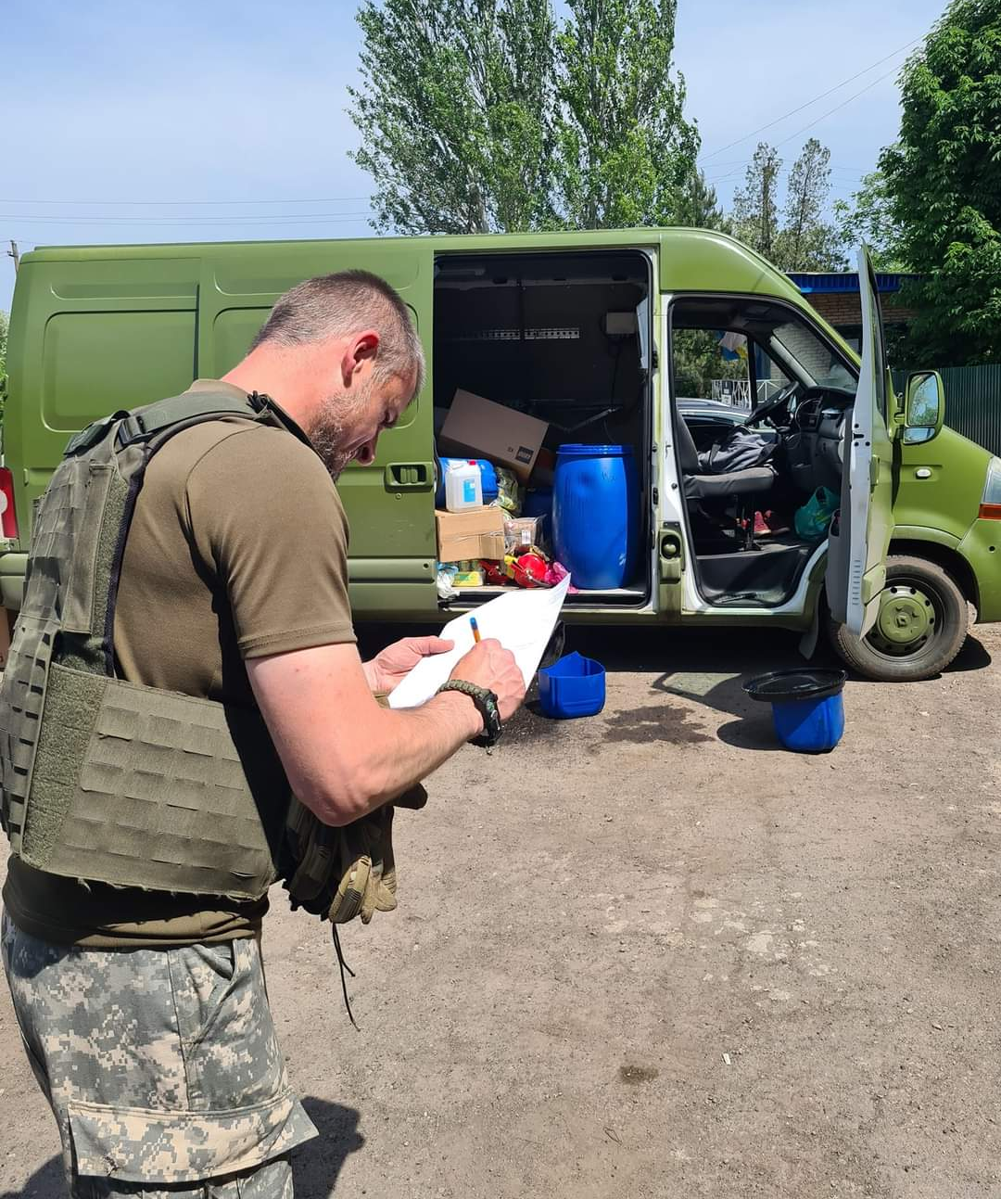
The Russian invasion began a year ago and the tragic war continues unabated, with untold killings and injuries, and suffering for the survivors who are left without homes, water or electricity. One hospital has 50 injured patients admitted every day, so that sending medical supplies is still a priority. The photo shows a doctor receiving some supplies at the hospital, having been delivered by our friends in Huddersfield : Tim Marsden and his merry men!! They take the supplies into the country and make sure it arrives where it’s supposed to be, and where its most needed. Any dressings, bandages, swabs, needles, syringes etc are so desperately needed that expiry dates don’t matter. Please contact us if you can help.
Here is Tim’s van loading up ready to head for the front with supplies for the soldiers. After delivery the van will be left with the men who will convert it into an ambulance. They are so grateful for all the supplies we send; the comfort boxes with essentials , the candle wax for their little stoves to cook the instant soups we send, the first aid packs etc, Many of them are under constant barrage, and are without water and the basics of life; but they are soldiering on, determined to save their country. Pray for all those delivering vital supplies . threat of cholera.
Yemen
The ongoing war in Yemen has resulted in over 17 million people in need of food.
This happy picture shows a Yemeni family excited about the contents of their
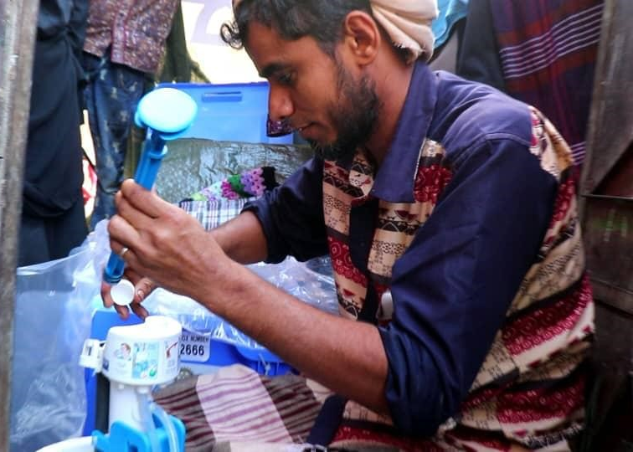
newly arrived box of aid supplies, and the one below shows one of the water filters Aquabox provide, being set up, so providing clean water for another family. in the ongoing fight Against diseases such as cholera which spread through the dirty water. Meanwhile thousands of Christians are being imprisoned, persecuted or killed, so that the country has now risen to 3rd in the Open Doors World Watch list. So please pray along with our brothers and sisters for peace and justice. Meanwhile we are working hard towards filling our 9th 40 foot container of aid to go out in early May. God bless you all for your support.

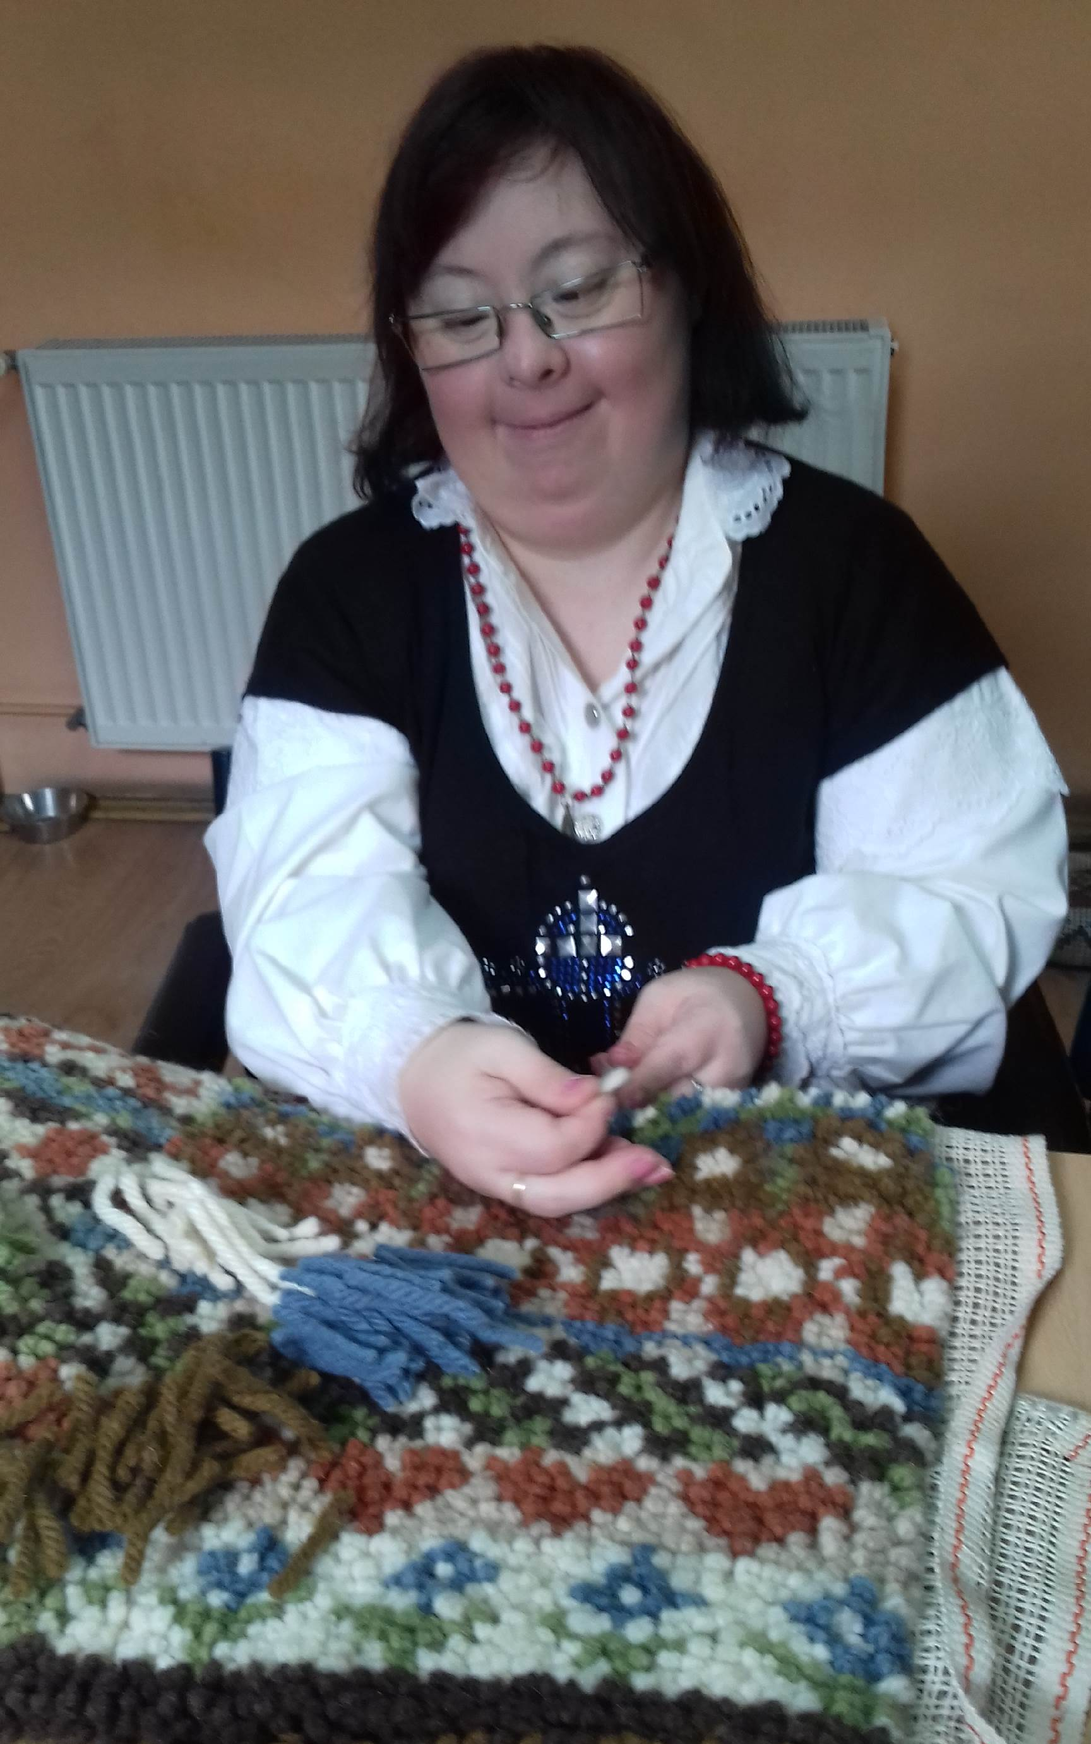
Clever Hands
Orsi writes that the centre for disabled youngsters has struggled after one of their minibuses died, they coped using their cars, but a car dealer has now found them another one. Meanwhile they have big dreams and aims. They are raising funds for a second day care centre!!! AND also a second care home!!!! They are doing more with parents: counselling, psychotherapy, and sharing the gospel, she says that is not so easy with new younger parents. So they are working and praying hard towards opening a second one home. Meanwhile they send their love and prayers to you all as we are able to continue sending funds quarterly. Please continue to pray for them as they work towards achieving their dream One of the youngsters making a rug.
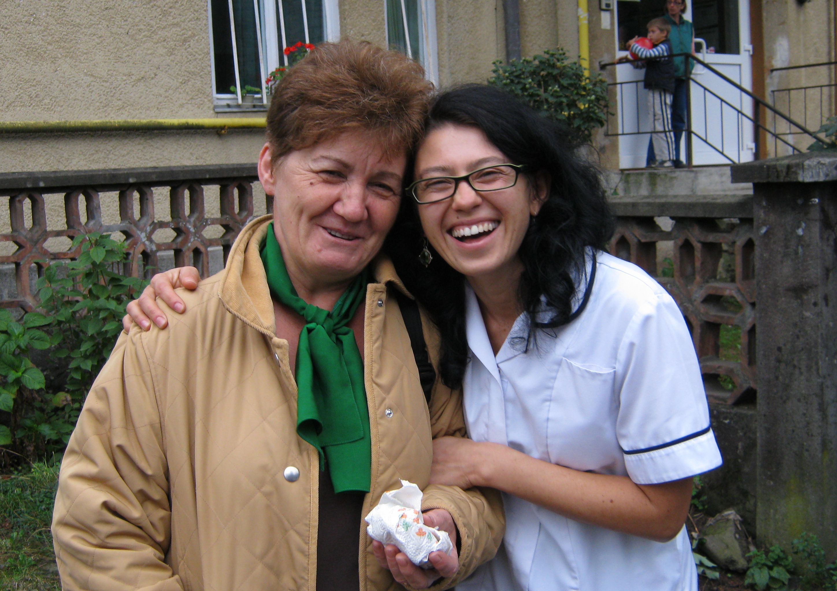
Medicare
Judit Finna writes that they have had a tough year with covid and flu, and she fell while skiing and ruptured her knee ligaments, resulting in surgery and Judit using crutches. The team are finding the heavy work load hard, especially Hunor and Imo who have small children. Here are Imo and Gizzy sharing a joke. |Judit writes:” Its definitely a 7 day miracle that we survived, and you have the biggest part in this miracle” They are so grateful that we still manage to send funding quarterly; thanks to those working in the 2 JOY shops and all those who send gifts. God bless you all.

Give thanks :
☺.. For all our friends and their wonderful work in Romania, Ukraine and Yemen.
☺.. For Alan Armitage who has volunteered not only to be our book keeper but a trustee as well, and has already sorted out the arrears of many months!
Please pray :
… For all our colleagues in the difficulties they face.

Published by:- Jubilee Outreach Yorkshire,

14 Jubilee Way, Shipley, West Yorkshire, BD18 1QG

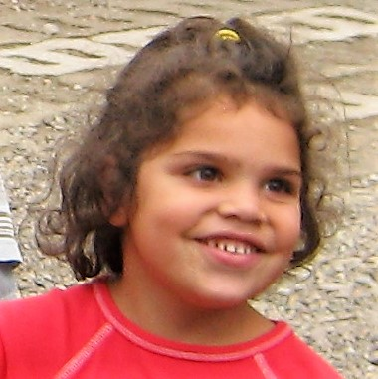

Jubilee Outreach Yorkshire
Newsletter No. 163
Spring 2023
 01274 - 531999
www.joyworld.org.uk
E mail: kathy@joyworld.org.uk
Reg. Charity No. 1144323

