**GODLY PLAY**

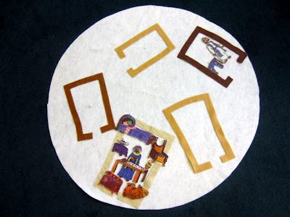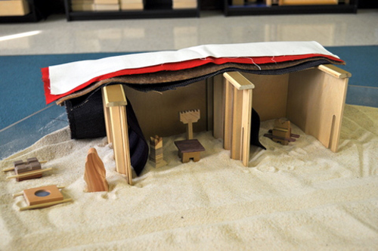**TASTER EVENING**

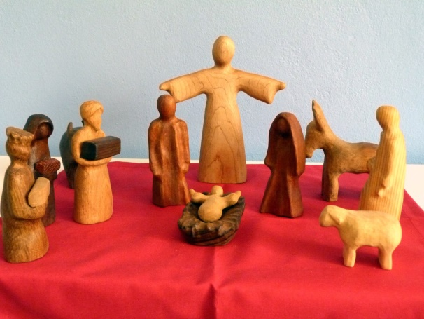

**Tuesday 11 October**

**7.30pm**

**St Matthew’s Church, Wilsden**

Godly Play is a way of telling Bible stories to All Ages, filled with Awe and Wonder. Perfect for Schools, Churches, Care Homes

The evening is free and is being led by Jan Hesselwood & Richard Burge

For more details contact Richard Burge on 01535 273758 or richard.burge@leeds.anglican.org